|  |
| --- |
|  |

*User Guide*

COVID TEST and VACCINATION System

**COVID.**

 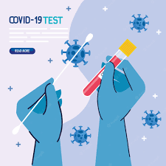 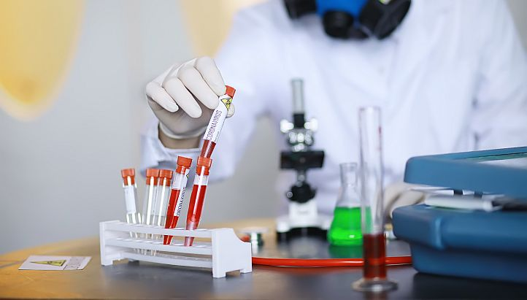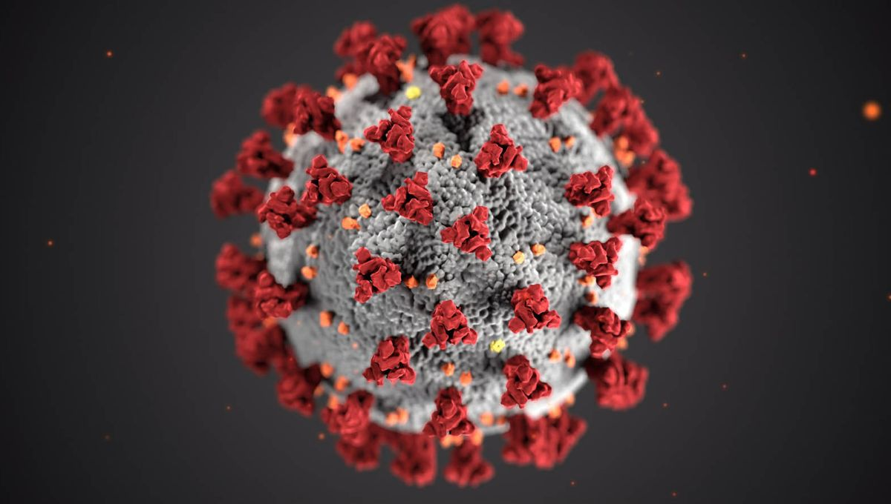

**E-PROJECT DOCUMENTATION**

**Faculty: SIR KHALID**

**BATCH CODE: 2111G1**

*COVID TEST AND VACCINATION SYSTEM*

**COVID.**

**Project Group Member**

* **Sayed usman shams**
  + **Enrollment NO: Student1350098**
* **Sayed bilal shams**
  + **Enrollment NO: Student1350097**
* **Abdullah baber**
  + **Enrollment NO: Student1351346**
* **MUHAMMAD Sameer ghori**
  + **Enrollment NO: Student1350060**

**PROJECT DATES:**

Issue date: 12-Nov-2022

Submission date: 12-Dec-2022

**FRONT END**

**HOME**

1. **Patient Login (login.php):**

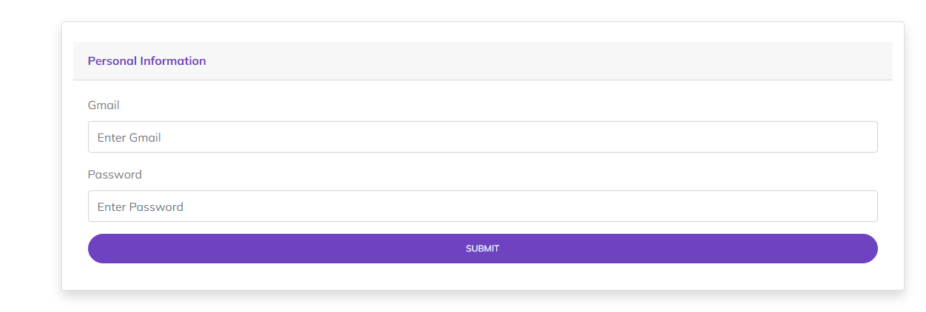

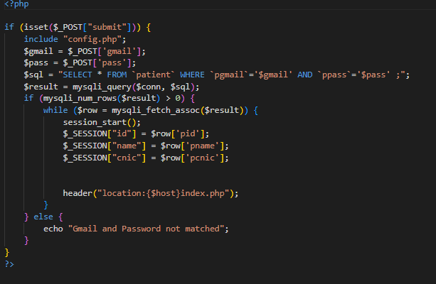

*Figure 1: Login page*

1. **PATIENT SIGNUP (SIGNUP.PHP):**

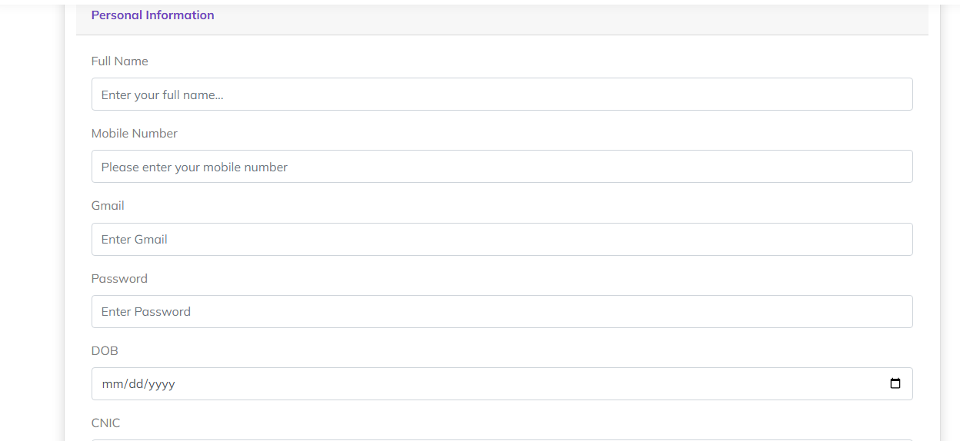

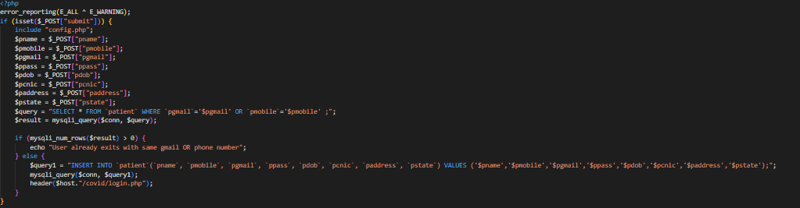

*Figure 2: Signup page* 

1. **HOME (INDEX.PHP):**

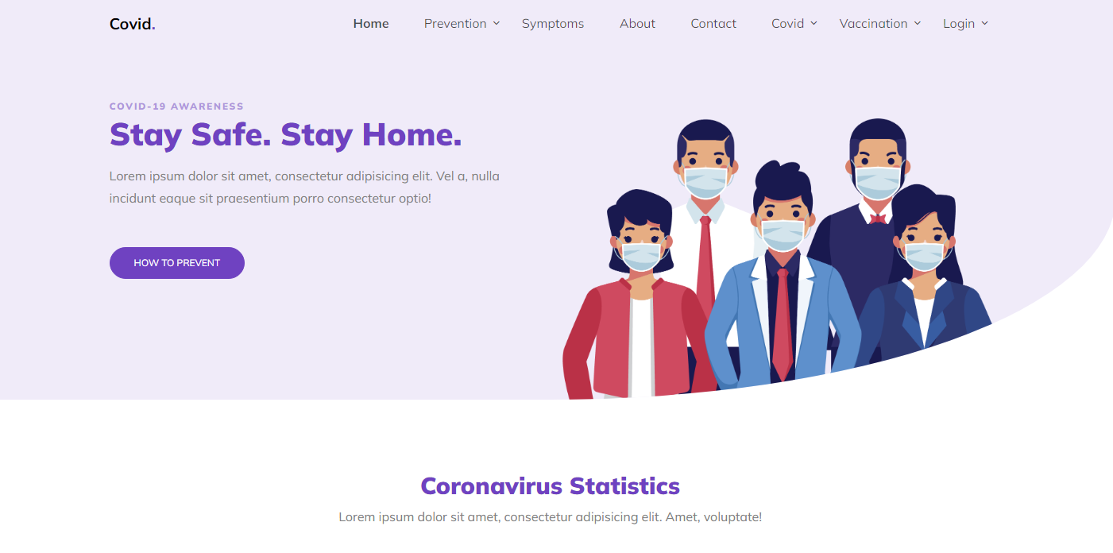

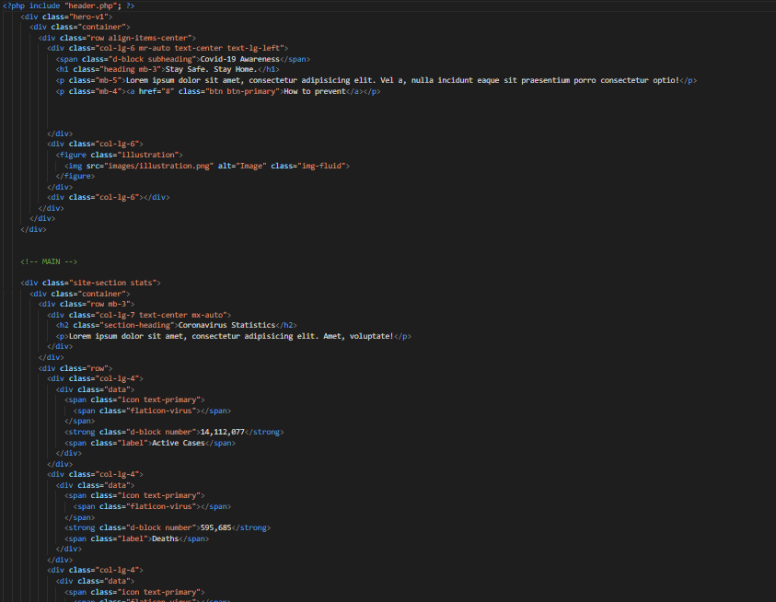

*Figure 3: Home page*

1. **NAVBAR (HEADER.PHP):**



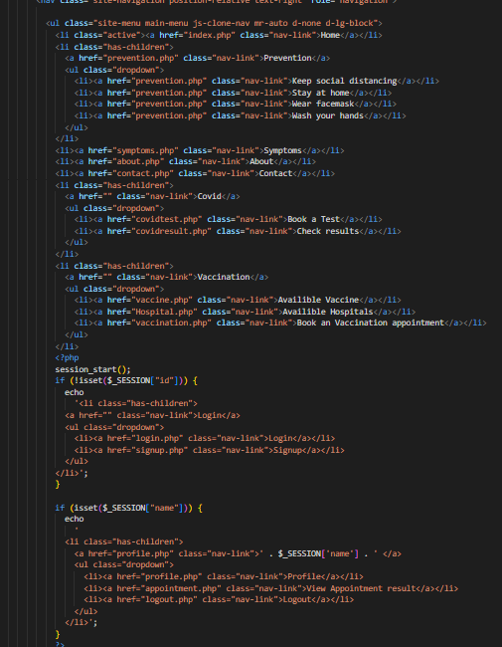

***Figure 4: Navbar***

1. **ABOUT US (ABOUT.PHP)**

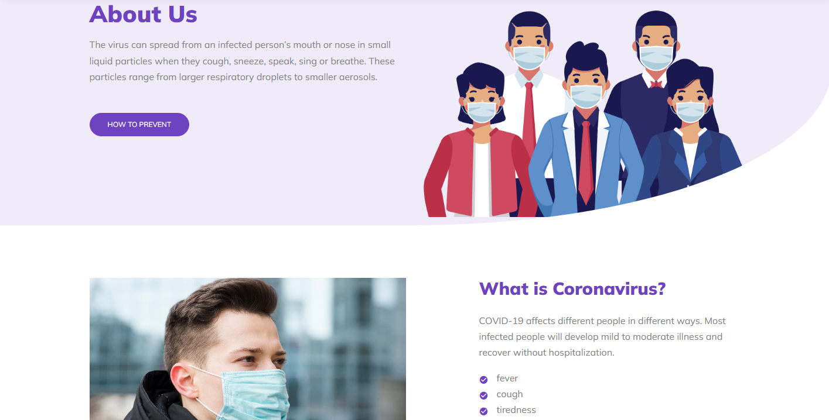

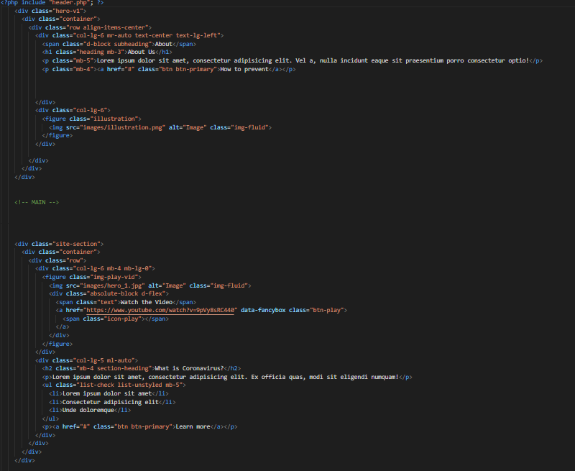

***Figure 5: About us***

**



1. **COVID APPOINTMENT (COVIDTEST.PHP)**

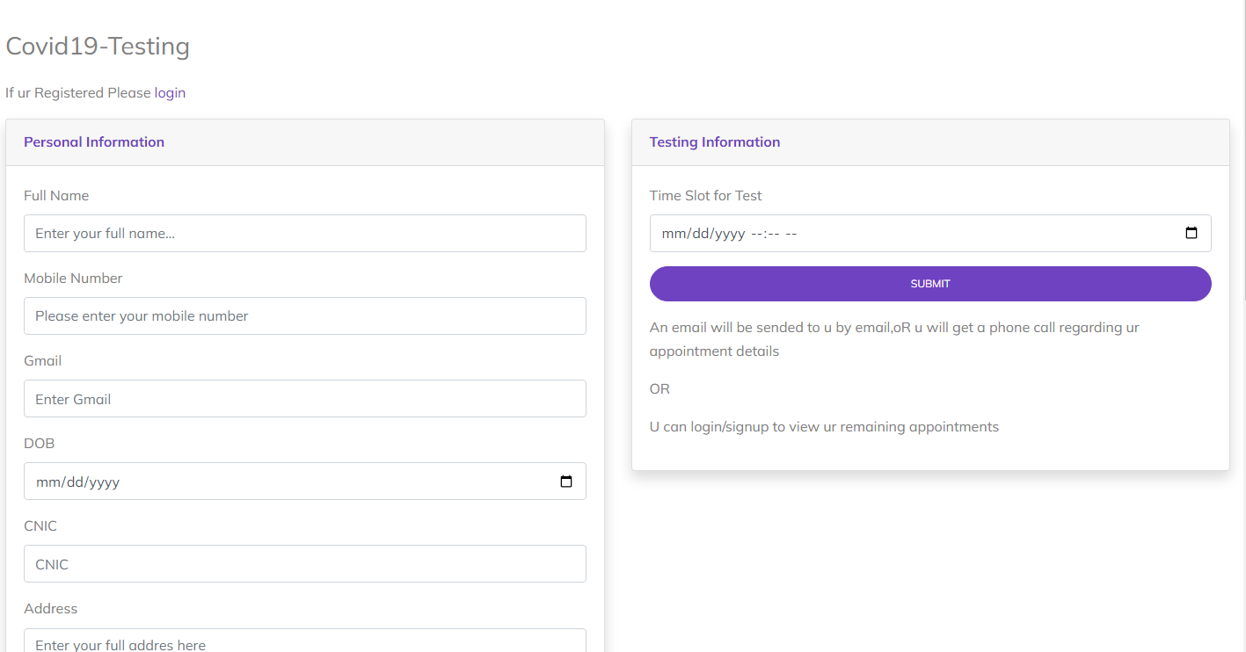

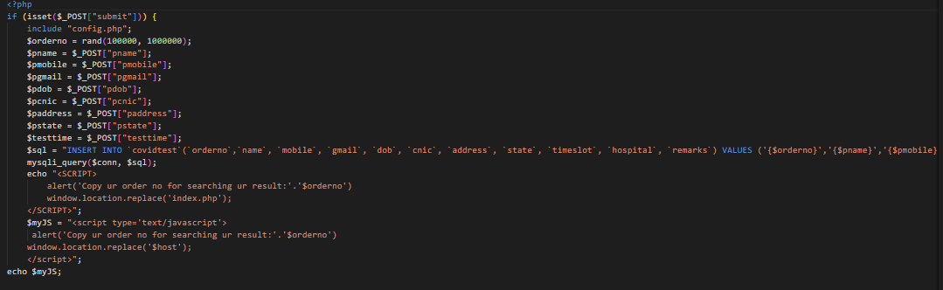

***Figure 6: Covid Test Appointment***

*We have mentioned our basic services to make people known about the service we provide.*

1. ***SEARCH REPORTS(COVIDRESULT.PHP)***

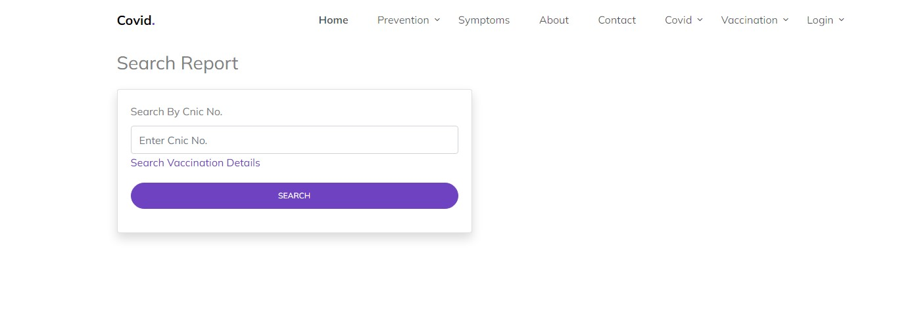

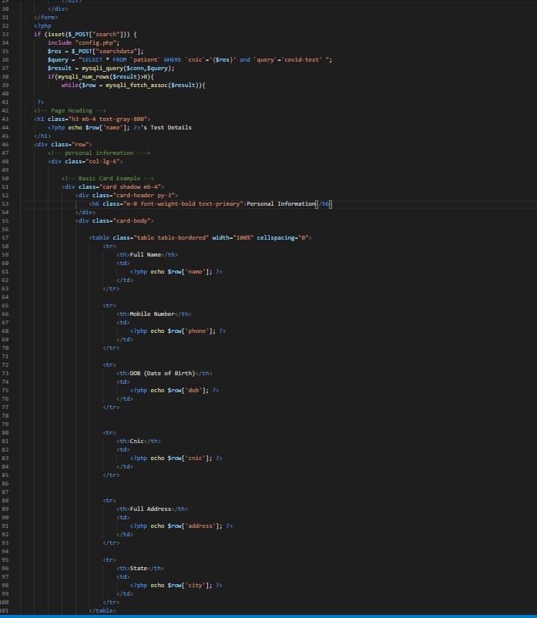

*Figure 7:Search Reports*

***SEARCH REPORTS(COVIDRESULT.PHP)***

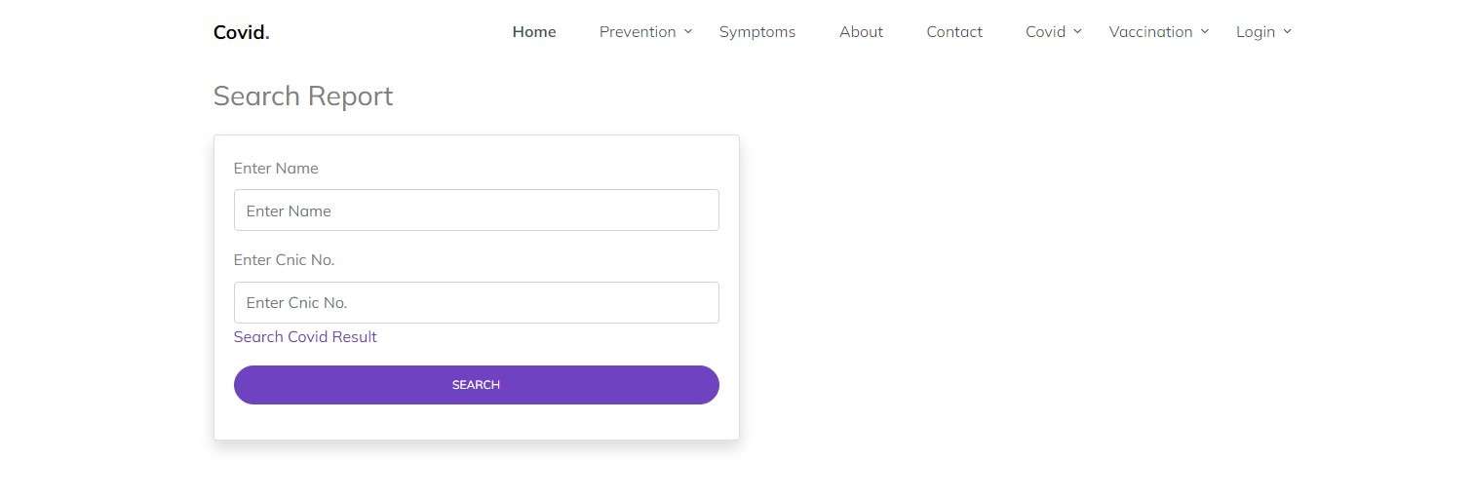

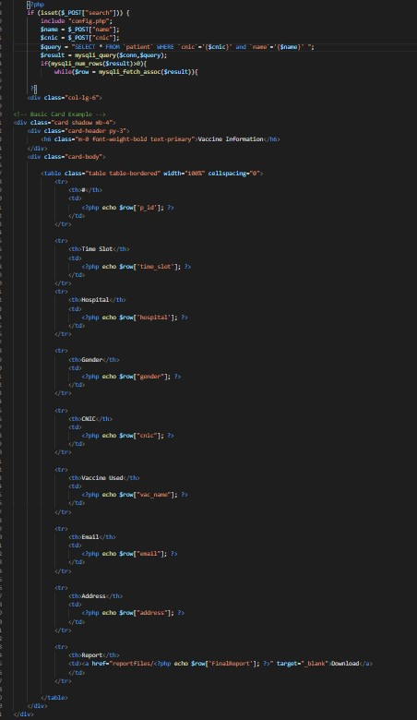

1. ***CONTACT US(CONTACT.PHP)***

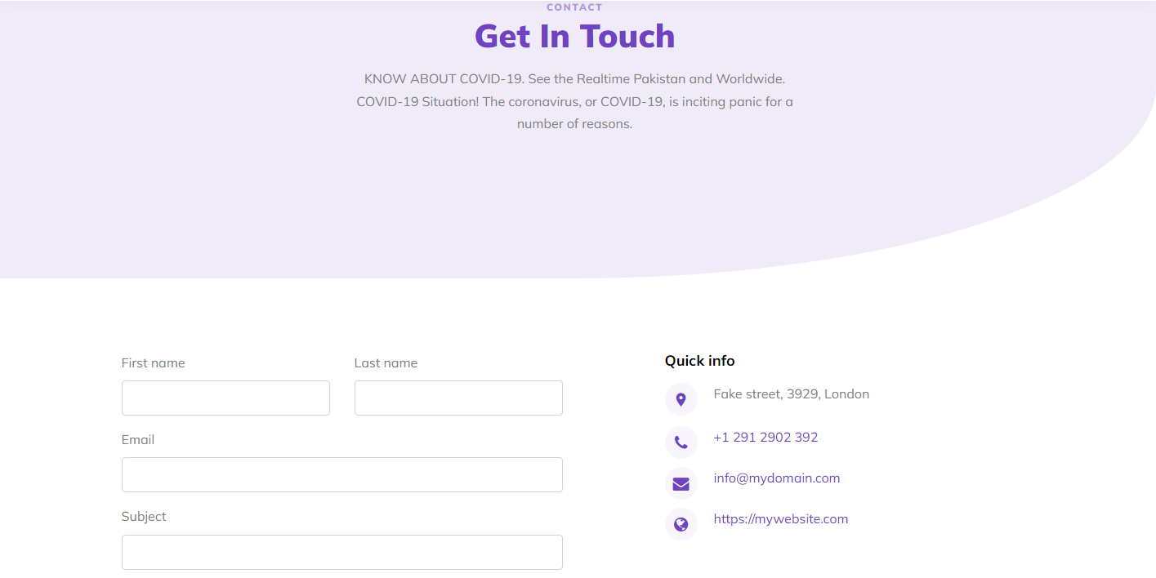

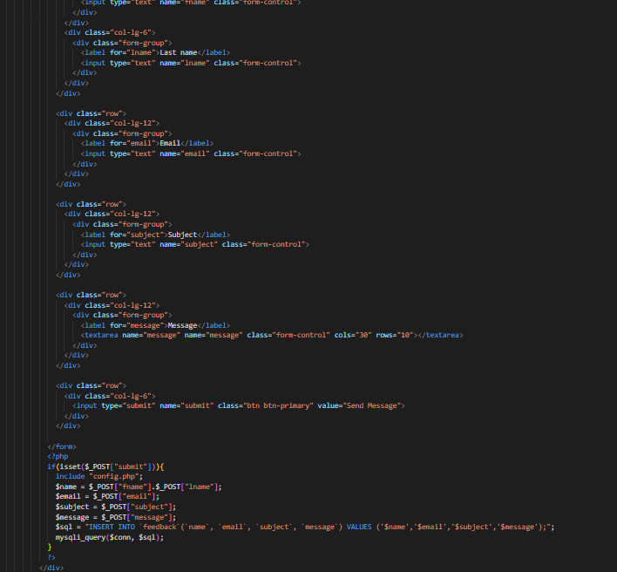



***Figure 8: Contact Us***

***9. AVAILABLE VACCINE(VACCINE.PHP)***

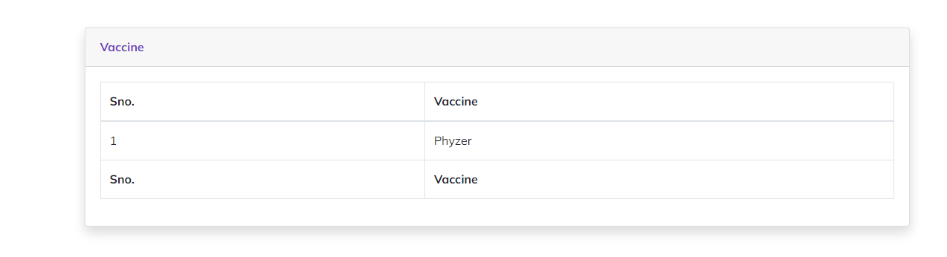

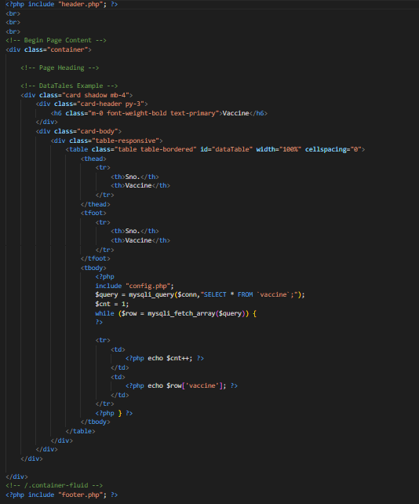

*Figure9:AvailableVaccines*

1. ***AVAILABLE HOSPITAL(HOSPITAL.PHP):***

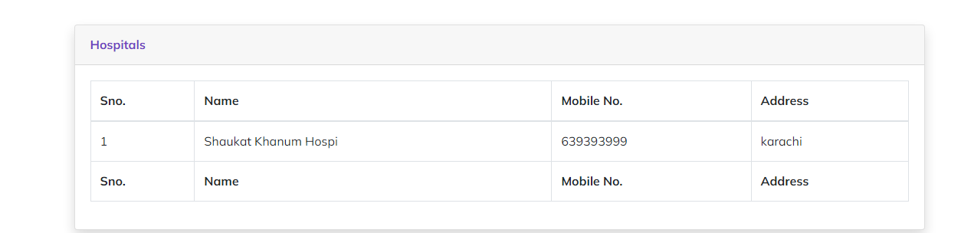

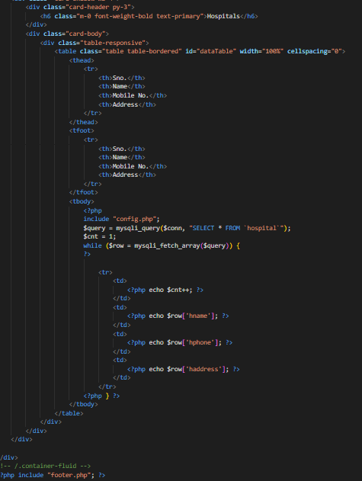

*Figure 10: Available Hospital:*

1. ***BOOK VACCINATION APPOINTMENT(VACCINATION.PHP):***

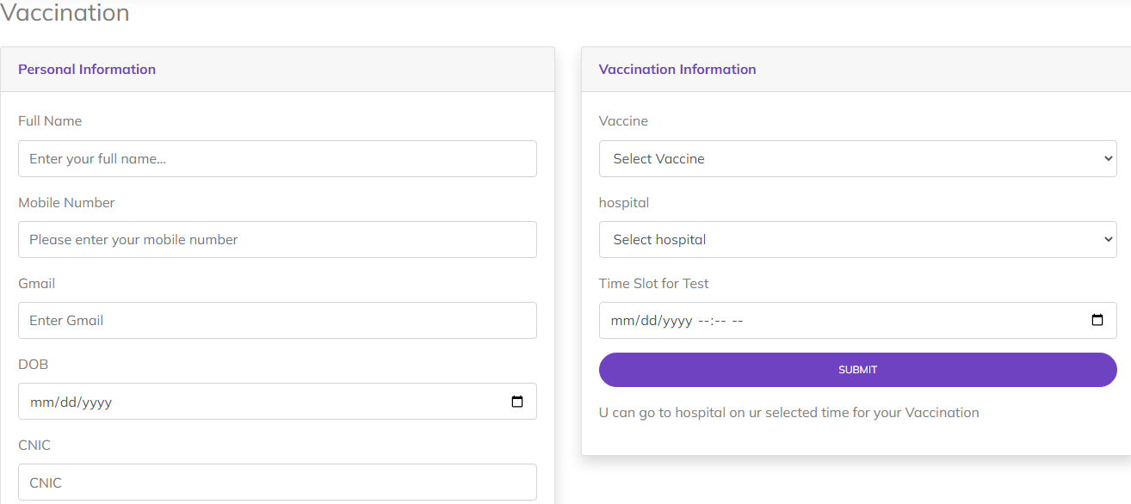

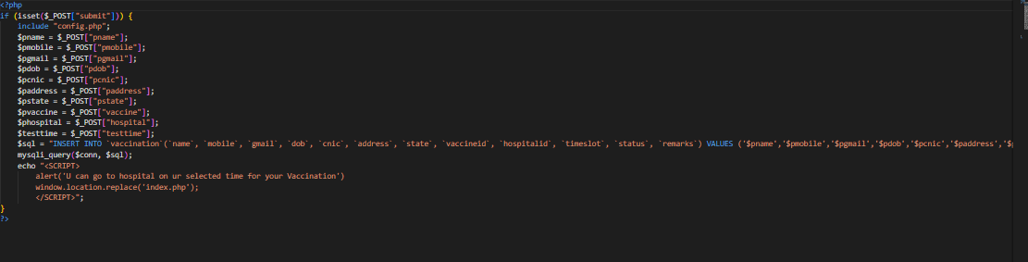

*Figure 11: Book Vaccine Appointment*

1. ***FOOTER(FOOTER.PHP):***

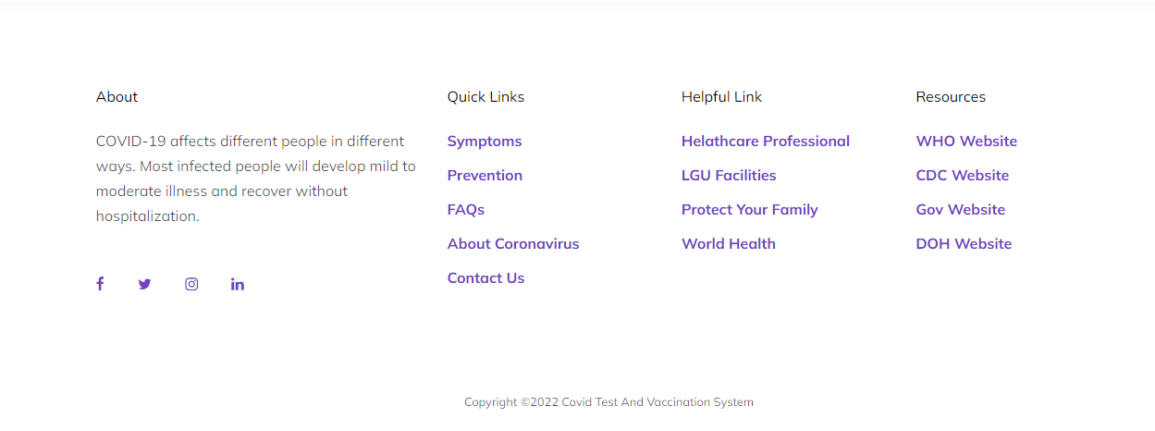

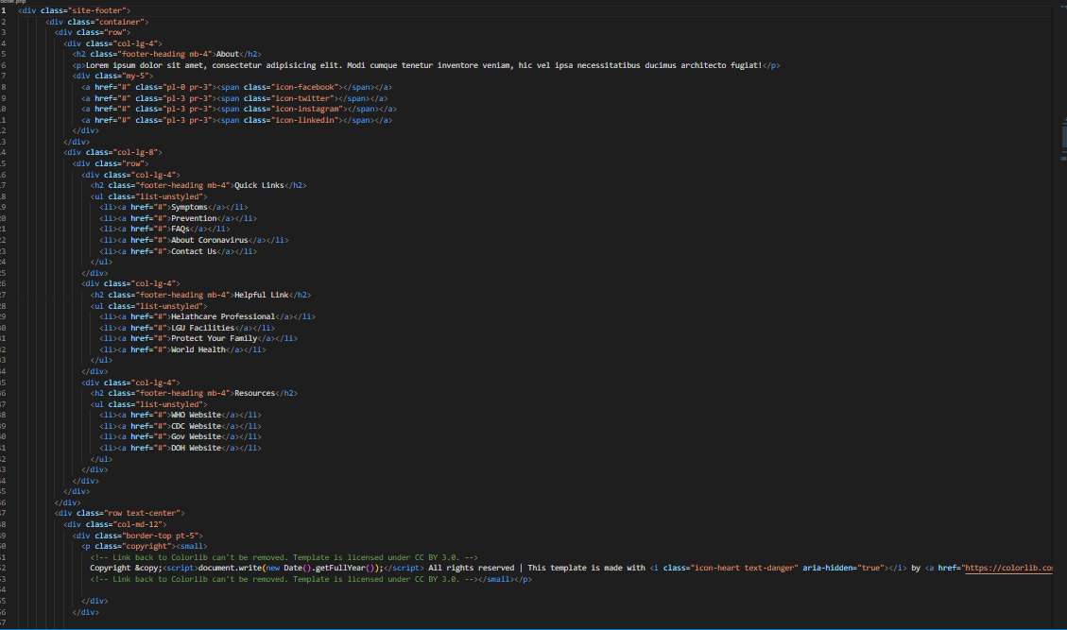

*Figure 12: Footer*

1. ***MENU BAR:***

***Use to load the remaining sections. The following is a list of those sections:***

*As we have work on only single page and re-directing on other sections. So, we are made our web directed pages.*

1. **PATIENT LOGIN (LOGIN.PHP):**
2. **PATIENT SIGNUP (SIGNUP.PHP):**
3. **HOME (INDEX.PHP)**
4. **NAVBAR (HEADER.PHP):**
5. **ABOUT US (ABOUT.PHP)**
6. **COVID APPOINTMENT (COVIDTEST.PHP)**
7. ***SEARCH REPORTS(COVIDRESULT.PHP)***
8. ***CONTACT US(CONTACT.PHP)***
9. ***AVAILABLE VACCINE(VACCINE.PHP)***
10. ***AVAILABLE HOSPITAL(HOSPITAL.PHP):***
11. ***BOOK VACCINATION APPOINTMENT(VACCINATION.PHP):***
12. ***FOOTER(FOOTER.PHP):***

***BACKEND***

***BACKEND LOGIN PAGE(LOGIN.PHP)***

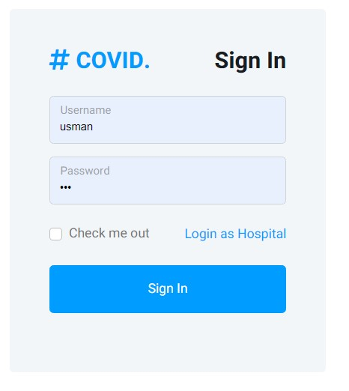

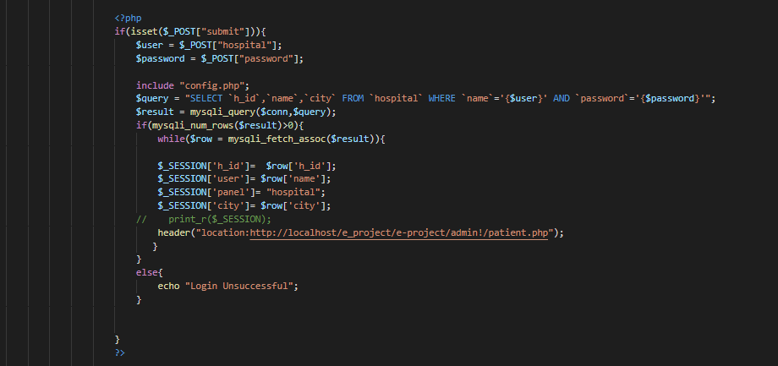

***BACKEND LOGIN PAGE(HOS-LOGIN.PHP)***

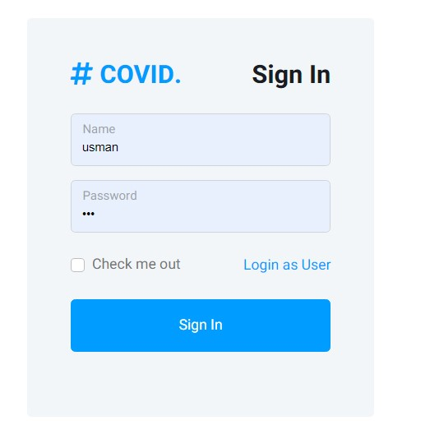

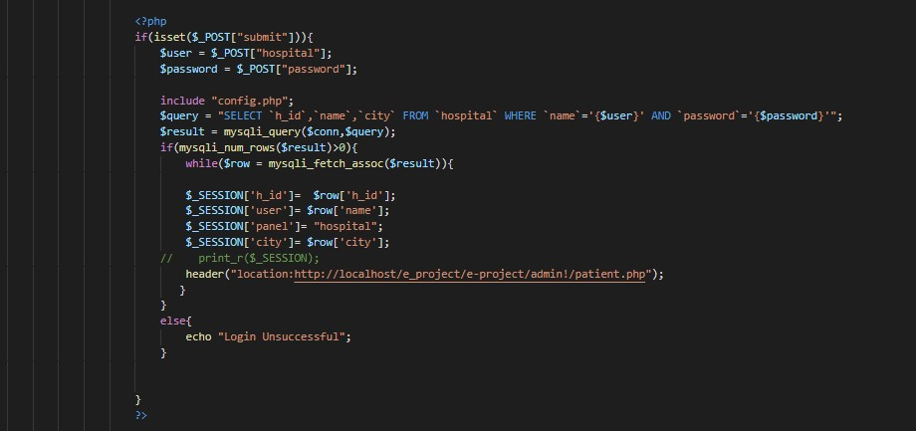

*Here you can login and login must required for enter the dashboard.*

***Dashboard (dashboard.php)***

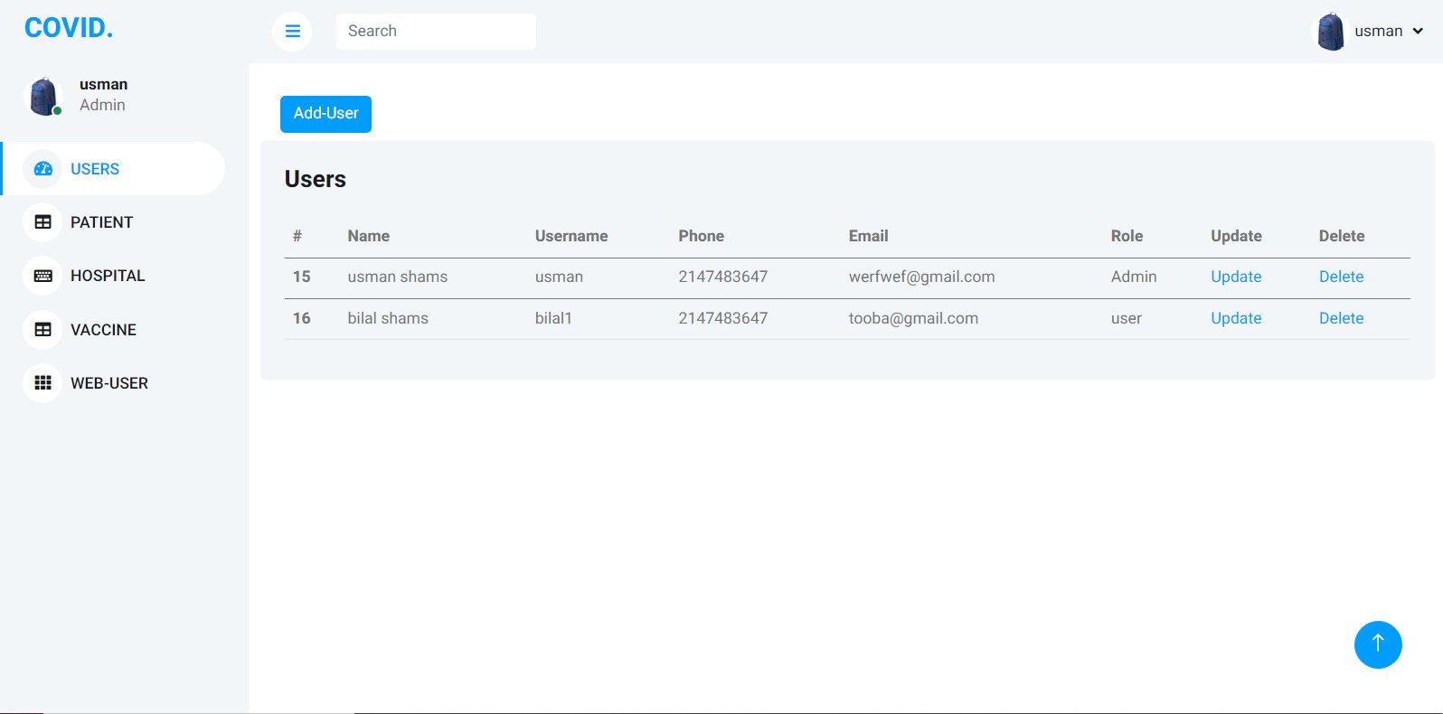

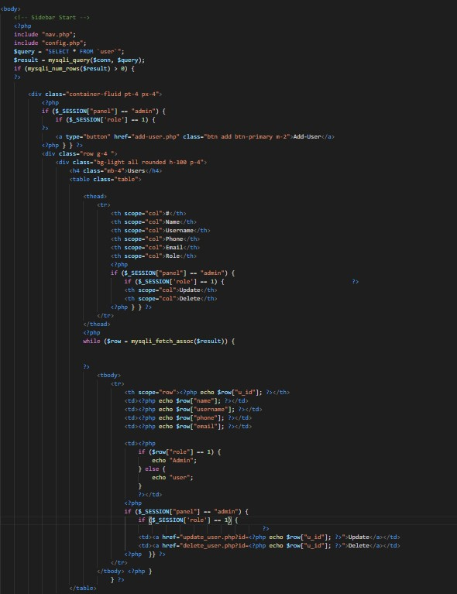

***Add hospital(addhospital.php)***

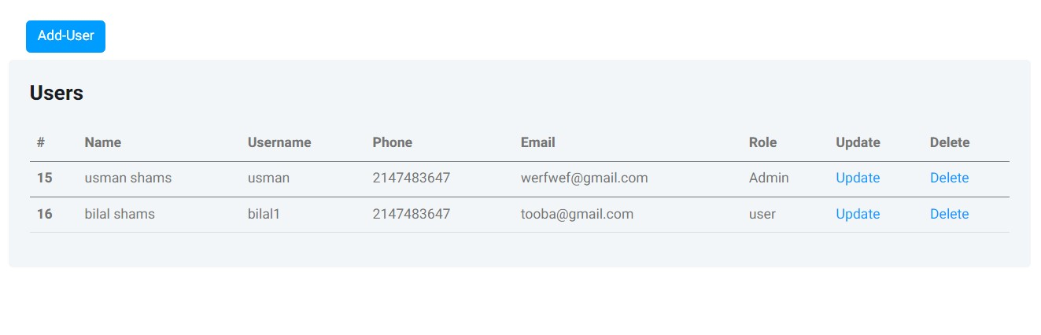

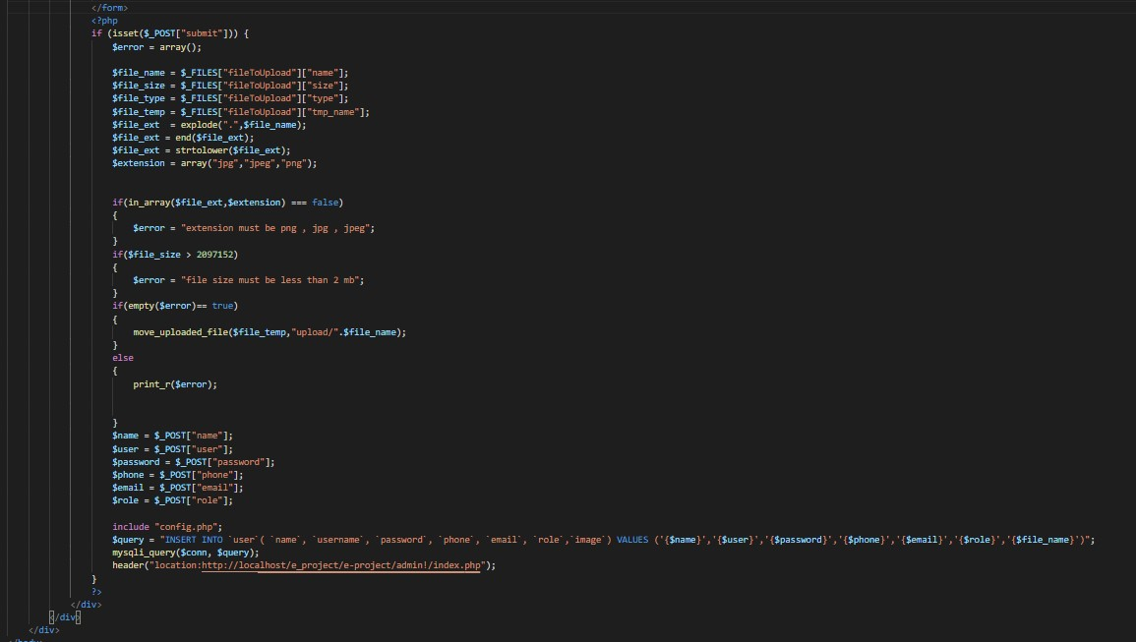

***Read hospital(Rhospital.php):***

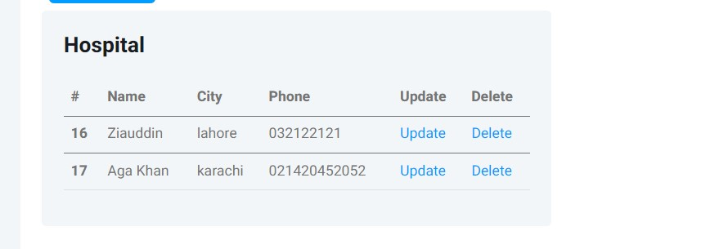

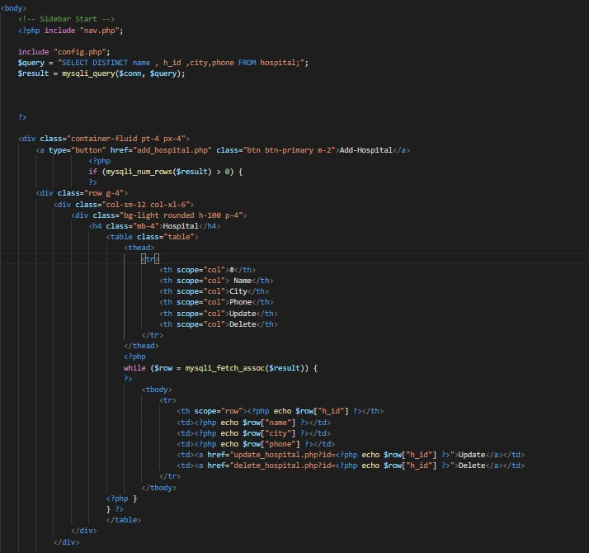

# Read Patient (RPATIENT.PHP)

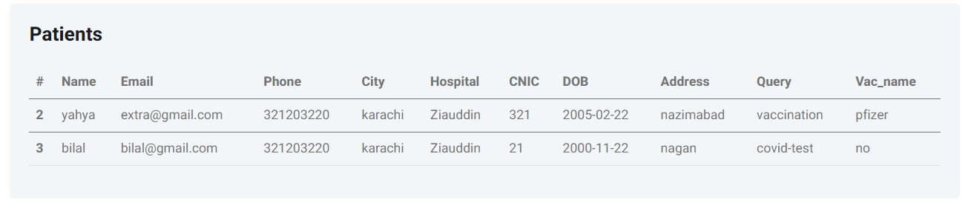

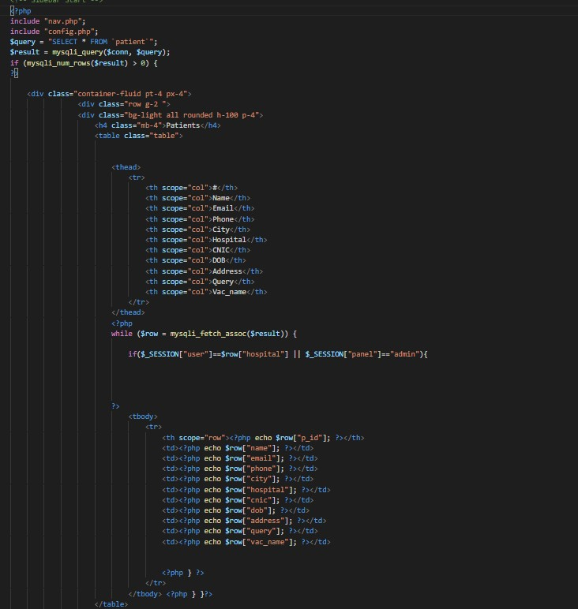

**Vaccination appointment(Vaccinationapplication.php)**

**ERD DIAGRAM(database/what.sql)**

`

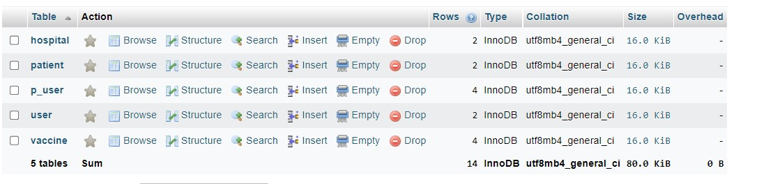

THANK YOU FOR READING THE DEVELOPER GUIDE.